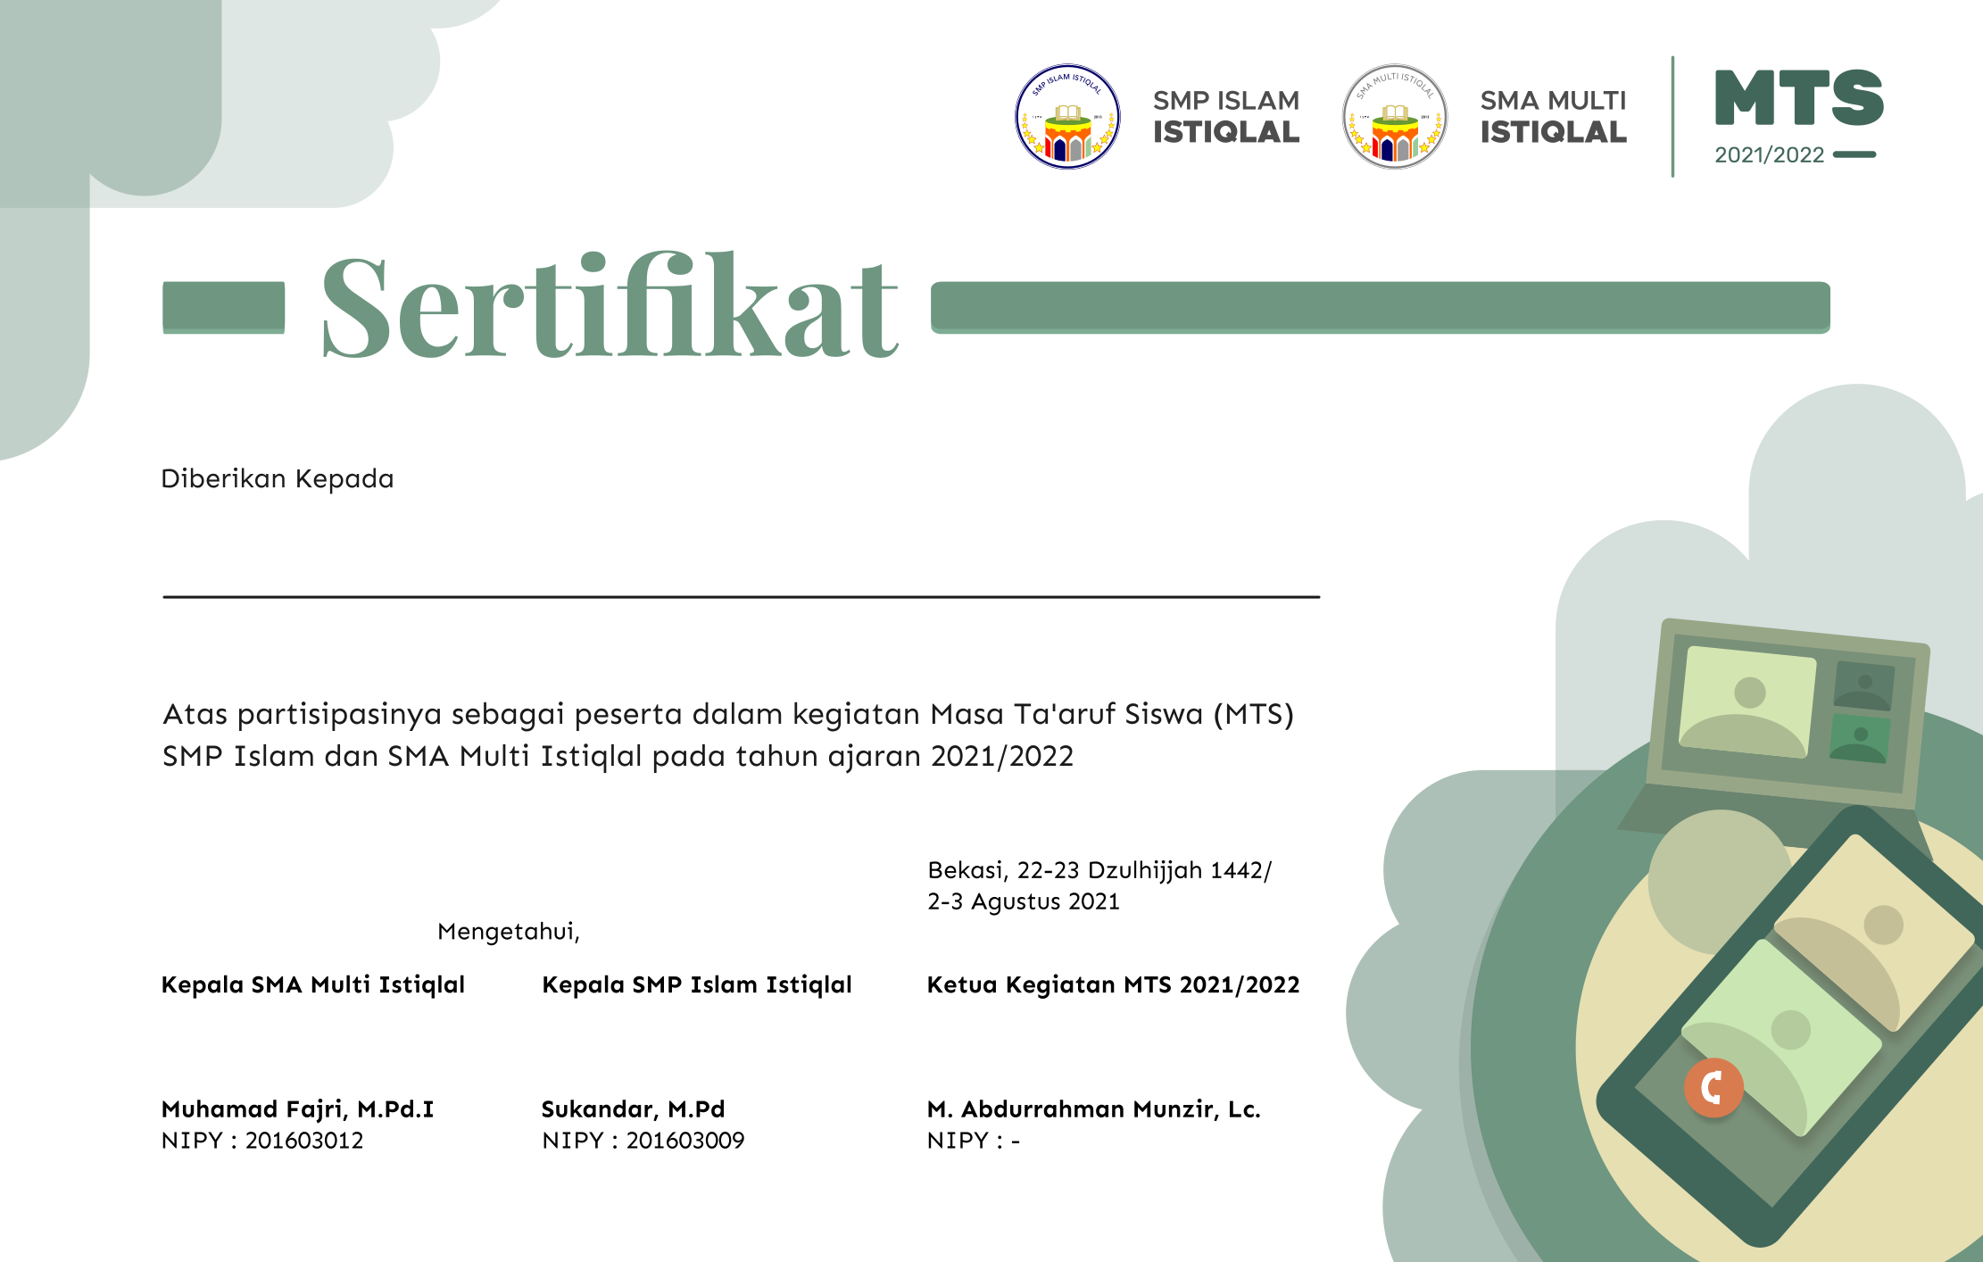

**Muhamad Faiz Ibnu Abdulloh Al-Ayash**

SMA Multi Istiqlal